## Microphone request for Amistad Chapel United Church of Christ – Technology Grant

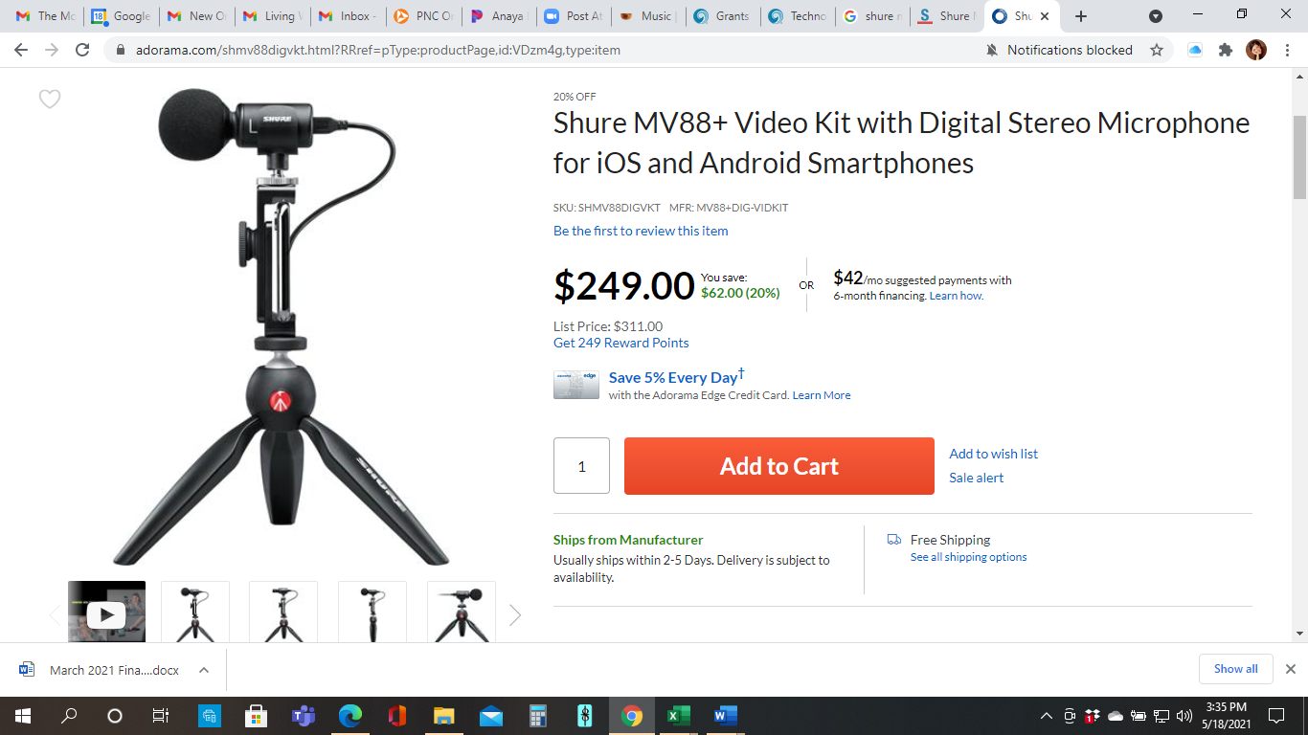

3 microphones at $249 each for a total of **$747**