**THE COST OF THE PROJECT**

Total cost of the project in local currency **25,581,500.00**/= Equivalent to **9336** **EUROS**

Local contribution **6,000,000**/= Equivalent to **2,190 EUROS**

Amount requested **19,581,500** Equivalent to **EURO 7,147**

**Bank Details**

**ACC. NAME: SUMBAWANGA DIOCESE PROJECTS**

**ACC N: 1950381420500**

**BANK NAME: CRDB BANK PLC**

**SWIFT CODE: CORUTZTZ**

**ELECTRICITY BILLS FOR THE KASITU CHURCH**

1. Holder PC 18 2000……………………………………………………….sh 36,000/=
2. String Pros Pc 15 4000……………………………………………………sh 60,000/=
3. Bulb pc 24 7000…………………………………………………………..sh 168,000/=
4. Wipe 1.5 mita 30 1400…………………………………………………..sh 42,000/=
5. P.V.C kiripsi Box 1………………………………………………………sh 4000/=
6. Payment……………………………………………………… ……………sh 300,000/=

**TOTAL……………………………………………………………….. .sh /=610,000/=**

**TOOLS NEED FOR**

|  |  |  |  |  |
| --- | --- | --- | --- | --- |
| NO. | ITEMS | PRICE | QUALITY | TOTAL |
| 1 | GYPSAUM BOARD | BOARD 70 | @19,000 | 1,330,000 |
| 2 | GYPSUM POWDER | SAC 160 | @35,000 | 5,600,000 |
| 3 | SHEETS | BANDLE 17 | @450,000 | 7,650,000 |
| 4 | NAILS | KIL. 40 | @5000 | 200,000 |
| 5 | GYPSUM BELT | 49 | @3500 | 1,71500 |
| 6 | SIMENT | 100 | @20,000 | 2,000,000 |
| 7 | SAND | TRIP 20 | @90,000 | 1,800,000 |
| 8 | CORAUL PAINT | BACKET 15@48,000 |  | 7,20,000 |
| 9 | OTHER MATERIALS |  |  | 500,000 |
| 10 | WORKERS |  |  | 5,000,000 |
|  |  |  |  |  |
|  | TOTAL |  | USD | 10,857.2 |
|  |  |  | EURO | 9,988.6 |
|  |  |  | TSH. | 24,971,500 |

The Christians had started as you can see the building of the church.

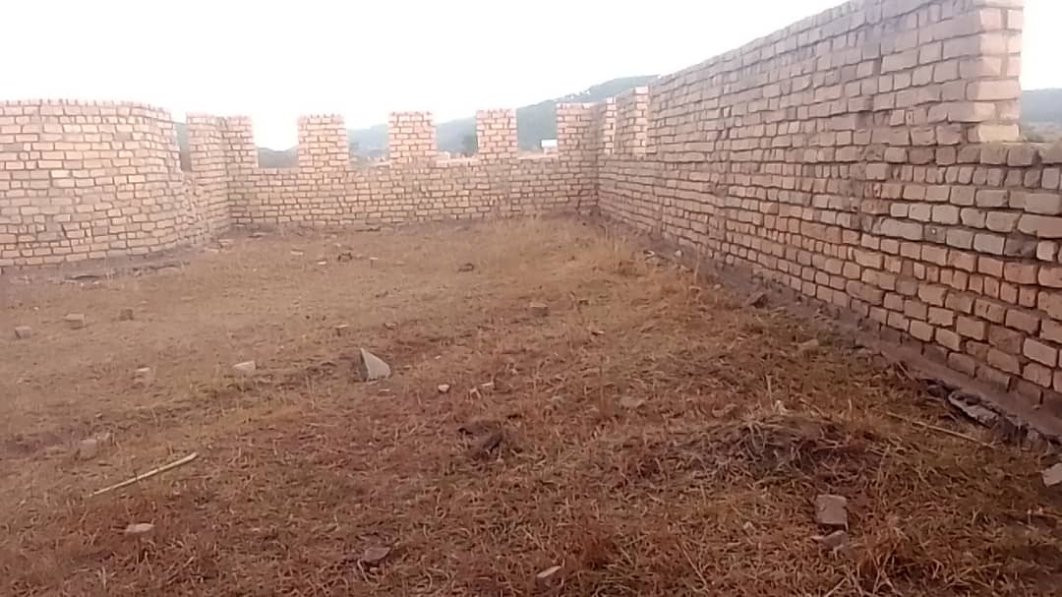

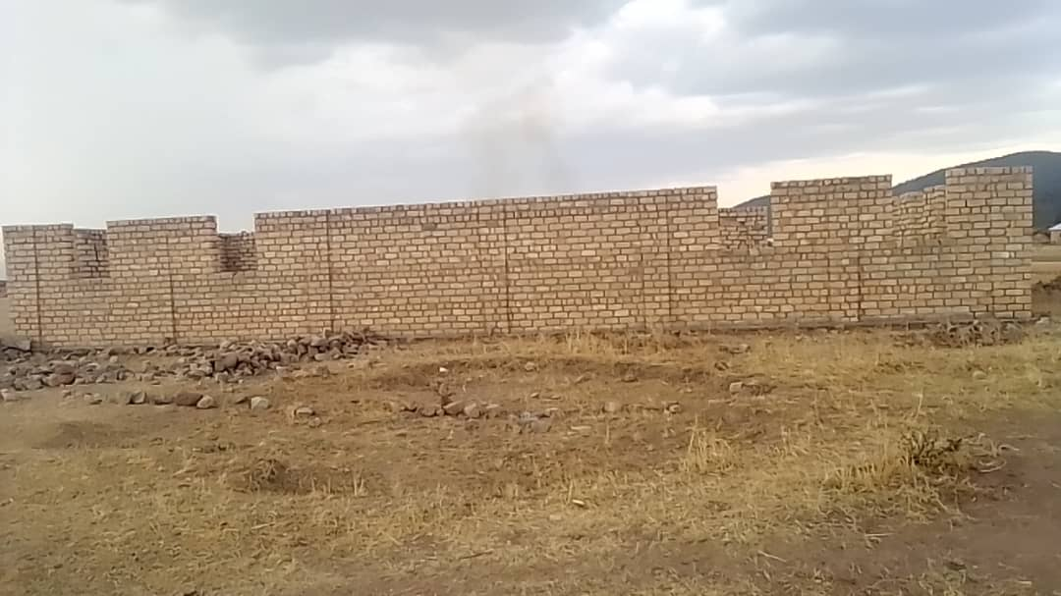

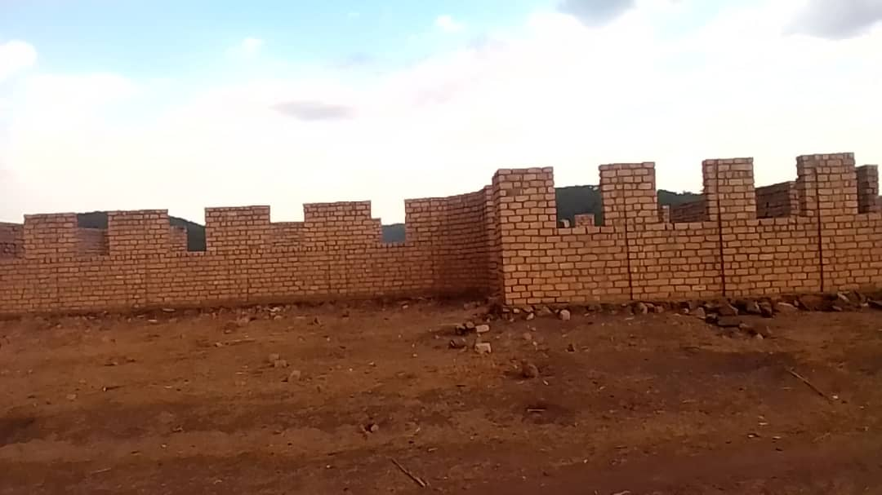

Those are the photos of the church of kasitu, It’s the hands and the contribution from the SOPA and the Kasitu church. That’s where they are now.. That’s why they need the helping hand so as their church will be done

**CONCLUSION**

Dear benefactors this project will help the Christian seek God in a quiet place, pray well and have enough security while in the church.