**Culinary Club/Class Projected Budget 2023-2024 School Year**

Hands-On Kitchen—Supplies/Ingredients: $500

School Activities/Outreach: $1,500

Field Trips: $1,500

**Total Estimate: $3,000**

**Mission Statement:**

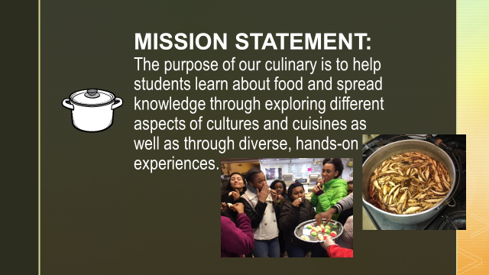

**Student Testimonials**

