**Line Item Project Budget** 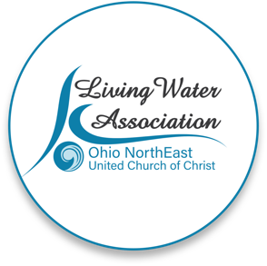

|  |  |  |  |  |
| --- | --- | --- | --- | --- |
| **Project Income** | **Anticipated** | **Committed** | **Total** | **Line Item Description** |

|  |
| --- |
| FAITH IN ACTION GRANTS APPLICATION |

Please provide details for each line item in your project budget. For example: **Foundations** - The Cleveland Foundation has awarded $15,000 listed under Committed column. **Other UCC Related Grants -** A proposal that is pending with a UCC Neighbors in Need Grant for $10,000 listed under Anticipated column.

|  |  |  |  |  |
| --- | --- | --- | --- | --- |
| Living Water Association | 4000 | 4000 | 4000 | $40 per family, 100 families |
| Other UCC Related Grants |  |  |  |  |
| Foundations |  |  |  |  |
| Organizational Budget (i.e.: individual contributions, fundraising, events/products, membership/fees/earned income, endowed income) |  |  |  |  |
| In-kind support |  |  |  |  |
| Other |  |  |  |  |
| **Total** | **$ 4000 -** | **4000** | **4000** |  |
| **Project Expenses** | **Living Water**  **Association**  **Funding Request** | **Other Funding** | **Total** | **Line Item Description** |

Please provide details for each line item in your project budget. For example: **Salary and Wages** - $1,500 in wages will support the Food Justice Coordinator to implement the program in congregational education and coordinating our food pantry distribution. Wages are calculated at 10% of the Coordinator's total time at a rate of $20/hr x 75 hours ($15,000 expected in wages for the year).

|  |  |  |  |  |
| --- | --- | --- | --- | --- |
| Salaries and wages |  |  |  |  |
| Consultants and professional services |  |  |  |  |
| Travel |  |  |  |  |
| Equipment |  |  |  |  |
| Office supplies/materials |  |  |  |  |
| Postage and mailing |  |  |  |  |
| Indirect expenses (i.e. rent/occupancy, utilities, maintenance) |  |  |  |  |
| Other | 4000 |  |  | Food staples |
| **Total** | **$ 4000 -** | **$ -** | **$ 4000 -** |  |

**If you have any questions regarding this process, please contact michael@livingwaterone.org or call (330) 814-7663.**