May 14, 2026

Living Water Association
Faith in Action Grants
960 Portage Trail
Cuyahoga Falls, OH 44221

To Whom it May Concern,

Avon Lake United Church of Christ is a member of the Living Water Association and partners with the Outdoor Ministries of the Heartland Conference. Our Director of Youth Ministries, Nate Taylor, coordinates and organizes the Sportscamp program currently being held at Camp Christian. It is our hope that our continued partnerships with all of these programs will grow both the Camp locations and the programs for more children and families to enjoy throughout the years.

If you need any further information in regards to this grant request, from our church or myself please do not hesitate to reach out.

Cordially,

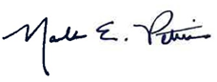
Rev. Mark Pettis
Sr Minister
Avon Lake United Church of Christ

