To: Living Water Association Council

From: Elena Larssen, Transitional Association General Minister

Date: September 18, 2025

Regarding: Quarterly Report to Council

*Gracious Friends, this ministry continues to be a blessing! I absolutely enjoyed General Synod with our Heartland community, and have continued to expand my knowledge and appreciation for our pastors (active and retired), congregations, and agencies. While there are problems to face, they are the problems that are the work of a judicatory, mostly handled under confidentiality. My work falls into five general areas:*

1. Congregational Resourcing:
   1. Search and Call Program
   2. Adjudication – meaning…listening to issues, offering counsel, connecting with resources, referring to appropriate church offices (COM, legal, etc.).
   3. SPIRE Center – LWA is negotiating an online space at the Damascus Project to house our intellectual materials and increase the connections between our SPIRE-Living Water folx
2. Pastoral Resourcing
   1. Vocational Counseling
   2. Committee on Ministry program
   3. Community of Practice program – We are planning a fall ‘open enrollment’ and training for new facilitators. The goal is to increase participation significantly in the next two to three years; LWA is at roughly only 30% of our active pastors, below our peer group.
   4. Adjudication
3. Wider Church Relations
   1. General Synod
   2. Heartland Conference duties (AGM Roundtable, Listening Sessions, consultation with Dave Long-Higgins, Interim Retreat work)
   3. Connecting with National Ministries/PBUCC/etc. for program and administrative needs
4. Organizational Life
   1. Staff coordination and relations (annual performance conversations occur in October)
   2. ExploratoryTeam - Verbal report to be presented by Rev. Dr. Monica Dawkins-Smith, Team Facilitator for the Exploratory Team.
   3. Finance and Budget with Machelle
   4. Communications and Annual Meeting planning with Kellie
5. Spiritual Leadership
   1. Officiating Ordinations and Installations
   2. Prayer with and for our members
   3. Visioning and holy conversations to deeply understand the needs of our people and discern the holy path forward.
   4. Pastoral writing and preaching to center our faith amid all we do.

*With respect, Dr. Larssen*

**Updates on Actions**

**Committee on Ministry**

* In-person All COM meeting for November 6, 2025; the COM will then break until the new year.
* Completion of a Fitness Review investigation, now in the confidential adjudication stage.
* Earl Rogers will serve as All COM Chair and David Hill will serve the rest of his term on COM as the chair of Oversight; we need a Chair for Discernment and are identifying a Chair for Credentialing. **We currently have roughly a dozen MID’s.**
* Our Fall “Healthy Practices” which fulfills the Boundary Training requirement for Authorized Ministers will be led by the Center for Transformational Leadership of the Southern New England Conference of the UCC; designed to keep working clergy on the leading edge of pastoral ethics, the content centers current best practices in clergy ethics for a diverse and changing world.

**Search and Call and Celebrations of the Association**

* Several searches have reached completion, with installations and an ordination to celebrate, including Mark Pettis at Avon Lake UCC (9/14), and these upcoming:
  + Jenn Bertoni to be ordained/installed as pastor at Silver Lake, 9/21 at 3 p.m.
  + Julie Western to be installed as pastor at First Congregational Huntsburg, 9/28 10 a.m.
  + Rusty Andrews to be installed as pastor at First UCC East Lake, 9/28 3 p.m.
  + Leila Jindra to be installed as pastor at Middleburg Heights Community UCC, 10/26 at 10 a.m.
  + Ordination of Suzy Lefelhocz (4 part covenant for hospital chaplaincy) Lakewood UCC, 11/9, 3 p.m.
* Additional matches that do not yet celebrations scheduled are as follows: Jeff Nelson at St. Michael’s Marshallville; Marilyn Panko at Burton Congregational; Dwight Woodward (first time license) Newbury United Community UCC.
* Interims and Designated terms are also a blessing to have in place: Ruth Garwood at Pilgrim UCC/DOC at Chardon; Jeff Jackson at First Congregational Brecksville; Bobby Burtt at West Park UCC.

**Sunday Worship Visits**

In June and July: Federated (to preach); postponed due to family emergency: Orrville; Trinity Canton.

Visits completed: Heartland Family Camp at Dunkirk; Bainbridge Congregational; First Congregational Akron; Zion North Canton.

Upcoming: Preaching at First Church Oberlin on 10/5; Interim and Transitional Skills Retreat 10/19; **Retirement Celebration for Dan Busch at Trinity UCC in Tiffin, OH, 44883;** preaching at Fairport Harbor, 11/2; Preaching at Community Congregational Amherst on 11/9

**Heartland Conference Duties**

* General Synod was a pleasant success, much appreciation to the Heartland Conference staff for staffing this whole process.
* Listening Sessions with Lisa Withrow – this the Heartland and Indiana Kentucky Conference joint reflection process about the possibilities of sharing ministry in the future. **Verbal Report from Dan Doty, Chair of the Heartland Board of Directors and LWA Association Member.**

Please note our upcoming SPIRE Offerings:   
October 14 – Speak Truth to Power: Influencing Sacred Change  
October 23 – Spiritual Strength: When the Nightmares Come

**Questions for Discussion**

* ***What words describe the ministry year behind us?***
* ***How can the Association deeply support our pastors in their total wellness?***
* ***If we could add one ministry to our Association life would it be: increased ethics training, a youth emphasis, or a philanthropy program?***

Respectfully,

The Rev. Dr. Elena Larssen

**Annual Meeting of the Living Water Association**

All Saints Day: Saturday, November 1, 2025  9:00 am - 1:00 pm  
First Congregational Church, 47 Aurora St, Hudson, OH 44236, USA

Theme and Focus Scripture: *Saltier and Saltier!: A Focus on Matthew 5:13*

Keynote Speaker: Rev. Derek Terry, Director of the Open and Affirming Coalition of the United Church of Christ

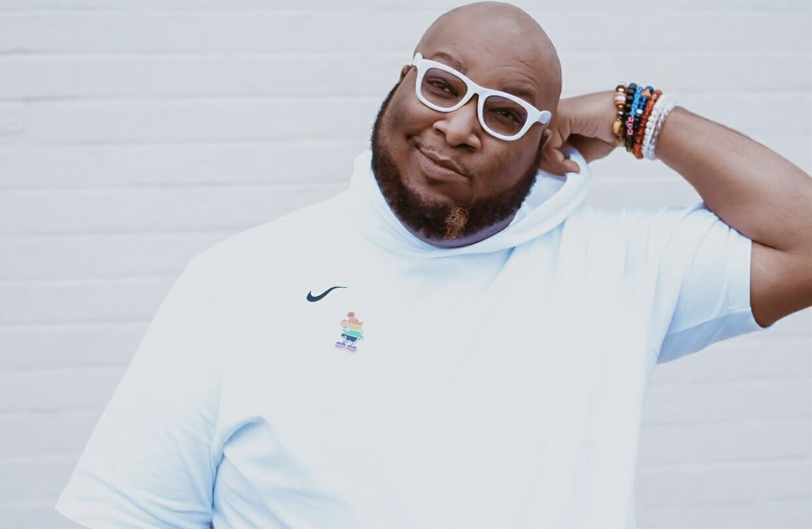

Featured Musicians: The Archwood UCC Jazz Combo

Partners attending: Dave Long-Higgins for the Heartland Conference; Beth Long-Higgins for United Church Homes, Amanda Powell UPCaM Campus Minister from [United Protestant Campus Ministries in Cleveland](http://upcam.org/), Inc.

Worship, Inspirational Keynote, Business, Lunch